AI Comic Studio: A Modular, Decoupled Architecture for Consistent AI-Assisted Sequential Art Generation
Contents
1. Introduction 3
1.1. Problem Definition 3
1.2. Aim of the Project 4
1.3. Scope of the Project 4
1.4. Limitations of the Project 5
2. Related Work & Literature Review 5
2.1. Similar Studies and the Evolution of Generative AI 5
2.3. The Shift from SDXL to Flux.1 6
2.4. Project Differences and Innovations 7
3. Methods and AI Fundamentals 7
3.1. Methodology 7
3.2. Hardware and Software Requirements 7
3.3. Generative AI Fundamentals: How the System "Draws" 7
3.4. Character Referencing Techniques 8
4. Project Management 9
4.1. Project Team and Roles 9
4.2. Scrum Implementation and Timeline 9
4.3. Risk Management 9
5. Requirements Analysis 10
5.1. Stakeholders 10
5.2. User Requirements 10
5.3. System Specifications 11
6. System Modeling 12
6.1. Context Diagram 12
6.2. Use Case Descriptions 13
6.3. Sequence Diagrams 14
7. System Architecture and Design 15
7.1. System Architecture 15
7.2. Structural Models 16
7.3. Behavioral Models 17
8. System Implementation 17
8.1. Development Environment 17
8.2. Code Structure 17
8.3. The Style LoRA Training Pipeline (Data Preparation & Fine-Tuning) 18
8.3.1. Data Collection 18
8.3.2. Ethical & Technical Filtering 18
8.3.3. Data Preparation & Captioning 18
9. MVP Development & Demonstration 19
9.1. MVP Definition 19
9.2. Implemented Features 19
9.3. System Demonstration: "The Cat in the Classroom" 19
10. Testing and Evaluation 19
10.1. Testing Strategy 19
10.2. Generative Adherence Testing 20
10.3. Network Latency Testing 20
11. Results and Discussion 20
11.1. Goal Attainment 20
11.2. Ethical Considerations 20
11.3. Cost Analysis 20
12. Conclusion and Future Work 21
12.1. Conclusion 21
12.2. Future Work 21
13. Appendices 21

Abstract
The rapid advancement of generative artificial intelligence, specifically latent diffusion models, has unlocked unprecedented capabilities in image synthesis. However, utilizing these models for sequential art—such as comic books or storyboarding—presents a critical challenge: temporal and spatial consistency. Early attempts at "single-prompt" comic generation fail because diffusion models struggle to maintain precise character identities, clothing, and compositional control across multiple distinct panels within a single generation step.
This capstone project presents AI Comic Studio, a novel, decoupled software architecture designed to solve the character consistency problem in AI comic generation. Rather than forcing the AI to generate a full comic page in one shot, we propose a highly modular pipeline. The system consists of a local, interactive web frontend (built with Next.js and React-Konva) and a remote, GPU-accelerated backend (FastAPI and ComfyUI running on Google Colab). By breaking the workflow into discrete stages—Character Sheet Generation, Panel-by-Panel Synthesis, and Interactive Layout Assembly—the system restores creative agency to the user. Furthermore, to enforce a unified aesthetic, a custom Style LoRA (Low-Rank Adaptation) was trained on a highly curated dataset and injected into a state-of-the-art Flux.1 diffusion pipeline. The resulting application allows users to generate highly consistent characters, place them into dynamic scenes, and assemble professional-grade comic layouts with interactive text layers, bridging the gap between raw AI generation and practical creative tooling.

1. Introduction

1.1. Problem Definition
The integration of generative AI into creative workflows has been hampered by a fundamental technical limitation inherent to diffusion models: the lack of zero-shot temporal and spatial consistency. In the context of comic creation, a user must be able to generate the exact same character—with identical facial features, hair, and clothing—across dozens of panels, viewed from different angles and exhibiting different expressions.
Initial approaches to AI comic generation relied on "single-prompt" paradigms, where a user would prompt an AI to "draw a 4-panel comic page of a girl with a black cat." While modern models can generate visually stunning single images, asking them to subdivide a single latent space into distinct, narrative panels almost universally results in catastrophic failure. The model hallucinates mixed clothing, morphs facial identities between panels, and ignores specific compositional requests. Furthermore, if the model succeeds in three panels but fails in the fourth, the user is forced to regenerate the entire image, thereby losing the three successful panels. This lack of granular control renders single-prompt generation unviable for serious sequential art.

1.2. Aim of the Project
The primary aim of this project is to design, develop, and evaluate a software system that solves the consistency and control problems of AI comic generation. Instead of treating comic generation as a single monolithic AI task, this project aims to build a modular, decoupled AI Comic Studio.
Specific objectives include:
- Separation of Concerns: Decoupling the image generation process from the layout and typography process.
- Character Consistency: Engineering a backend pipeline capable of generating consistent characters and injecting them into new scenes using advanced referencing techniques (e.g., IPAdapters, InstantID, and LoRAs).
- Interactive Assembly: Developing a rich, interactive web interface (Frontend) that allows users to drag, drop, scale, and arrange AI-generated panels onto a customizable canvas.
- Stylistic Cohesion: Training a custom neural network adaptation (Style LoRA) to ensure all generated images adhere to a specific, professional comic aesthetic, preventing the generic "AI look."

1.3. Scope of the Project
The scope of this capstone project encompasses both the engineering of the software architecture and the machine learning pipeline required to power it.
- Frontend Application: A local web application built with Next.js, React, and Zustand for state management. It includes an HTML5 Canvas implementation (via React-Konva) for complex layout manipulation and speech bubble rendering.
- Backend API: A Python-based FastAPI server designed to run on remote GPU hardware (Google Colab). It manages SQLite databases, handles Google Drive file storage, and proxies requests to the inference engine.
- Inference Engine: Integration with ComfyUI, utilizing complex JSON-based node graphs to run the Flux.1 [dev] diffusion model.
- Model Training: The collection, ethical filtering, and captioning of a massive dataset of comic art to train a custom Style LoRA, which is subsequently integrated into the inference engine.

1.4. Limitations of the Project
While the proposed architecture significantly improves upon single-prompt methods, the system operates under several technical constraints:
- Hardware Dependency: Generating high-fidelity images using models like Flux.1 requires significant VRAM (typically >16GB). Therefore, the backend cannot run on standard consumer laptops and is strictly dependent on remote GPU instances (e.g., Google Colab Pro).
- Network Latency: Because the frontend runs locally and the backend runs in the cloud, all large image tensors and UI payloads must traverse secure tunnels (ngrok/Cloudflare). This introduces unavoidable network latency, particularly when fetching high-resolution generation previews.
- Colab Session Volatility: The reliance on Google Colab means the backend environment is ephemeral. Sessions can timeout or disconnect, requiring robust state persistence (via Google Drive) and graceful error handling on the frontend.
- Text Rendering in Latent Space: Diffusion models are notoriously poor at spelling and typography. Therefore, rather than attempting to generate speech bubbles natively within the AI images, this system forces all text rendering to be handled as an interactive vector layer on the frontend canvas.

2. Related Work & Literature Review

2.1. Similar Studies and the Evolution of Generative AI
The field of generative artificial intelligence has experienced an exponential trajectory over the past three years. Early systems like DALL-E and initial versions of Stable Diffusion proved that translating natural language into visual data was possible. Academic studies surrounding these models initially focused on raw image quality and resolution. However, as the technology matured, the academic focus shifted toward controllability and consistency.
Recent literature has heavily scrutinized the inability of standard diffusion models to maintain identity. Studies on methods like Textual Inversion, DreamBooth, and LoRA (Low-Rank Adaptation) demonstrated that while you can teach a model a specific face or style, preventing the model from "forgetting" or warping that data when placed in complex, multi-subject scenes remains a largely unsolved problem in zero-shot generation. This project builds upon these studies by acknowledging that prompting alone is insufficient for sequential art, necessitating external architectural scaffolding to enforce consistency.

2.2. Commercial Products
Several commercial platforms have attempted to bridge the gap between AI generation and comic creation. Products such as ComicAI and MangaMaker offer user-friendly interfaces for generating comic pages. However, these systems generally rely on black-box, proprietary models (often wrappers around Midjourney or heavily censored enterprise APIs).
While these commercial products are accessible, they severely restrict user agency. Users cannot inject their own fine-tuned character LoRAs, nor can they utilize advanced local control network techniques like spatial masking. Furthermore, the commercial models often impose their own "house style," preventing artists from achieving a unique aesthetic. Our project differentiates itself by providing a fully transparent, open-source-driven pipeline where the user retains absolute control over the character models and the final aesthetic.

2.3. The Shift from SDXL to Flux.1
A critical inflection point in this project was the migration from the SDXL (Stable Diffusion XL) architecture to the newly released Flux.1 architecture.
During early prototyping, our backend utilized SDXL. While SDXL offered excellent base resolutions (1024x1024), it suffered from two fatal flaws when applied to comic panels:
- Poor Prompt Adherence: When prompted with complex scenes (e.g., "a girl in a blue uniform sitting at a desk while a boy stands behind her"), SDXL would frequently suffer from "concept bleeding." The boy might end up wearing the blue uniform, or the model might merge the two characters into one entity.
- Anatomical Failures in Dynamic Poses: Comic art requires dynamic, expressive posing. SDXL struggled severely with hand anatomy, foreshortening, and complex interactions (like a character holding an object).
The release of Flux.1 [dev] provided a necessary paradigm shift. Flux utilizes a massive 12-billion parameter transformer-based architecture (significantly larger than SDXL). In our testing, Flux demonstrated near-perfect prompt adherence, successfully segregating concepts within the latent space and rendering complex multi-character interactions without bleeding. The migration to Flux was therefore mandatory to achieve the level of panel-by-panel control required for this system.

2.4. Project Differences and Innovations
Unlike both raw model interfaces (like standard ComfyUI or Automatic1111) and commercial comic generators, the AI Comic Studio operates on a paradigm of Decoupled Sequential Generation. By separating character instantiation (Character Sheets) from narrative execution (Panel Generation), and further separating the visual art from the typography (Canvas Assembly), this system mirrors a traditional comic book workflow (Penciler, Inker, Letterer) using AI as the execution engine rather than the absolute author.

3. Methods and AI Fundamentals

3.1. Methodology
This project utilized an Agile, iterative prototyping methodology. Development was divided into distinct, functional sprints:
- Establishing the UI canvas and drag-and-drop mechanics.
- Building the FastAPI backend and secure tunneling pipeline.
- Integrating the inference engine (SDXL, later migrating to Flux).
- Refining character consistency via LoRA training and IPAdapters.

3.2. Hardware and Software Requirements
Due to the computational weight of the Flux.1 [dev] model, the system architecture mandates a split-hardware approach.
- Frontend: A standard consumer machine (Windows/macOS) capable of running Node.js and a modern web browser.
- Backend: A remote Linux instance equipped with high-VRAM GPUs. In our implementation, we utilized Google Colab Pro instances equipped with NVIDIA A100 and H100 GPUs.
- Software Stack: Next.js (TypeScript), TailwindCSS, React-Konva (Frontend); Python, FastAPI, SQLite, ComfyUI (Backend).

3.3. Generative AI Fundamentals: How the System "Draws"
To understand the engineering challenges of this project, it is necessary to briefly define how the underlying AI models synthesize images.
Diffusion models do not "paint" from scratch. Instead, they operate on a principle of iterative denoising. The process begins with a tensor of pure Gaussian noise. Over a series of steps, a neural network—guided by a textual prompt processed by a text encoder (like CLIP or T5)—predicts and subtracts the noise, slowly revealing a coherent image.
This process occurs in a highly compressed mathematical representation known as Latent Space. Because the AI is navigating a probabilistic space based on its training data, slight variations in the prompt or the initial random seed result in vastly different trajectories. This inherent randomness is why achieving spatial and temporal consistency across multiple panels is mathematically difficult; the model is fundamentally designed to produce unique variations rather than exact replicas.

3.4. Character Referencing Techniques
To combat the inherent randomness of diffusion, we evaluated several advanced referencing techniques to force the model to "remember" a character across panels:
- Spatial Masking (Inpainting): Masking specific areas of an image and regenerating them. While useful for fixing small errors, it is too tedious for generating entire new poses from scratch.
- FaceID / Roope: Post-processing techniques that swap a generated face with a reference face. We discarded this approach because it often results in uncanny, pasted-on faces that lack the stylized shading required for comic art.
- InstantID & PuLID: Advanced control networks that extract facial embeddings from a reference image and inject them directly into the diffusion process.
- IPAdapter (Image Prompt Adapter): A neural network module that allows the diffusion model to use an image as a prompt, rather than just text, transferring the "vibe," clothing, and color palette of a reference image to the new generation.
Our Chosen Architecture: We concluded that the most robust method for comic consistency is a hybrid approach. The system relies on a Style LoRA to enforce the global comic aesthetic, while utilizing Textual Inversion/Embeddings and highly structured Character Prompting to maintain identity. In advanced workflows, PuLID is injected into the Flux pipeline to mathematically anchor the facial structure to the character sheet.

4. Project Management

4.1. Project Team and Roles
Due to the scope of this capstone, the project was managed as a full-stack engineering endeavor. The primary roles encompassed:
- Frontend Engineering: Designing the React UI, managing complex client-side state with Zustand, and implementing the vector graphics canvas using Konva.
- Backend & DevOps Engineering: Writing the FastAPI Python server, managing the SQLite database, integrating Google Drive persistence, and maintaining the secure tunneling architecture via ngrok/Cloudflare.
- Machine Learning Ops (MLOps): Curating the dataset, training the custom Style LoRA, and architecting the complex JSON node graphs required for ComfyUI headless inference.

4.2. Scrum Implementation and Timeline
The project was executed using an adapted Scrum methodology, broken down into specific Sprints to manage risk and ensure incremental delivery:
- Sprint 1 (Infrastructure & UI Baseline): Setup of the Next.js frontend and basic FastAPI routing. Implementation of the Konva canvas and drag-and-drop slots.
- Sprint 2 (SDXL Integration & Character Pipeline): Initial integration with ComfyUI. Development of the Character Sheet generation pipeline and database storage.
- Sprint 3 (The Flux Migration): A pivotal sprint where the inference engine was entirely rewritten to support the Flux.1 architecture to solve prompt adherence failures identified in Sprint 2.
- Sprint 4 (LoRA Training & Assembly Stabilization): Dataset collection, ethical filtering, captioning, and the successful training of the custom comic Style LoRA. Implementation of the vector text bubble system on the frontend canvas.

4.3. Risk Management
The project required active mitigation of several high-impact technical risks:
- Dependency Conflicts: The backend required precise versions of torchvision and Pillow to support ComfyUI. Conflicts were mitigated via strict requirements.txt pinning and automated installation scripts on Colab boot.
- GPU Session Loss: Colab sessions can terminate unexpectedly. To prevent data loss, the SQLite database and all generated images were configured to sync continuously to a mounted Google Drive volume.
- Network Instability: Reverse proxy tunneling (ngrok) can fail or introduce CORS issues. The frontend was engineered with robust polling mechanisms to verify backend health before attempting to send large image generation payloads.

5. Requirements Analysis

5.1. Stakeholders
The primary stakeholders for this system are comic artists, writers, storyboarding professionals, and AI hobbyists who require high fidelity and consistency in sequential art generation, but lack the technical expertise to manually configure complex ComfyUI node graphs.

5.2. User Requirements
The system requirements were derived from the limitations of existing single-prompt generators.
Functional Requirements (FR):
- FR-1: The user shall be able to generate and save persistent "Character Sheets" defining a specific identity.
- FR-2: The user shall be able to generate individual comic panels by referencing a previously saved character.
- FR-3: The user shall be able to drag and drop generated panels onto a predefined page layout.
- FR-4: The user shall be able to overlay customizable text layers (speech bubbles, narration boxes) onto the assembled page.
- FR-5: The user shall be able to export the final assembled page as a high-resolution image or PDF.
Non-Functional Requirements (NFR):
- NFR-1 (Aesthetic Consistency): The system must generate all images adhering to a unified comic style, preventing jarring aesthetic shifts between panels.
- NFR-2 (Responsiveness): The local UI canvas must maintain 60 FPS while dragging and resizing high-resolution image panels.
- NFR-3 (Availability): The system must handle the inherent latency of remote GPU generation gracefully, providing visual loading feedback (skeleton states) rather than freezing the UI thread.

5.3. System Specifications
The system is specified as a decoupled client-server model:
- Data Entities: Character, CharacterVariation, CharacterSheet, Panel, ComicPage, LayoutSlot, SpeechBubble.
- Communication Protocol: Standard HTTP REST API for data mutations (CRUD operations) combined with long-polling/asynchronous task tracking for image generation jobs.

6. System Modeling

6.1. Context Diagram
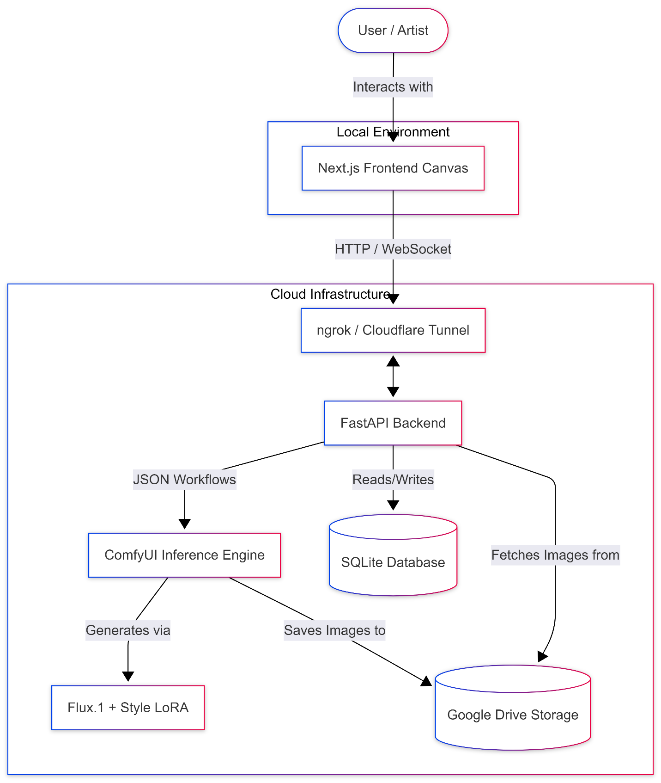
The system context involves the User interacting directly with the Local Next.js Studio Client. The Client communicates securely over the internet via a Secure Tunnel (ngrok) to the Remote Colab Runner. The Runner orchestrates the FastAPI Server, which in turn commands the ComfyUI Inference Engine (which utilizes the Flux model and LoRA weights). Finally, the Server reads and writes persistent data to Google Drive Storage.

6.2. Use Case Descriptions
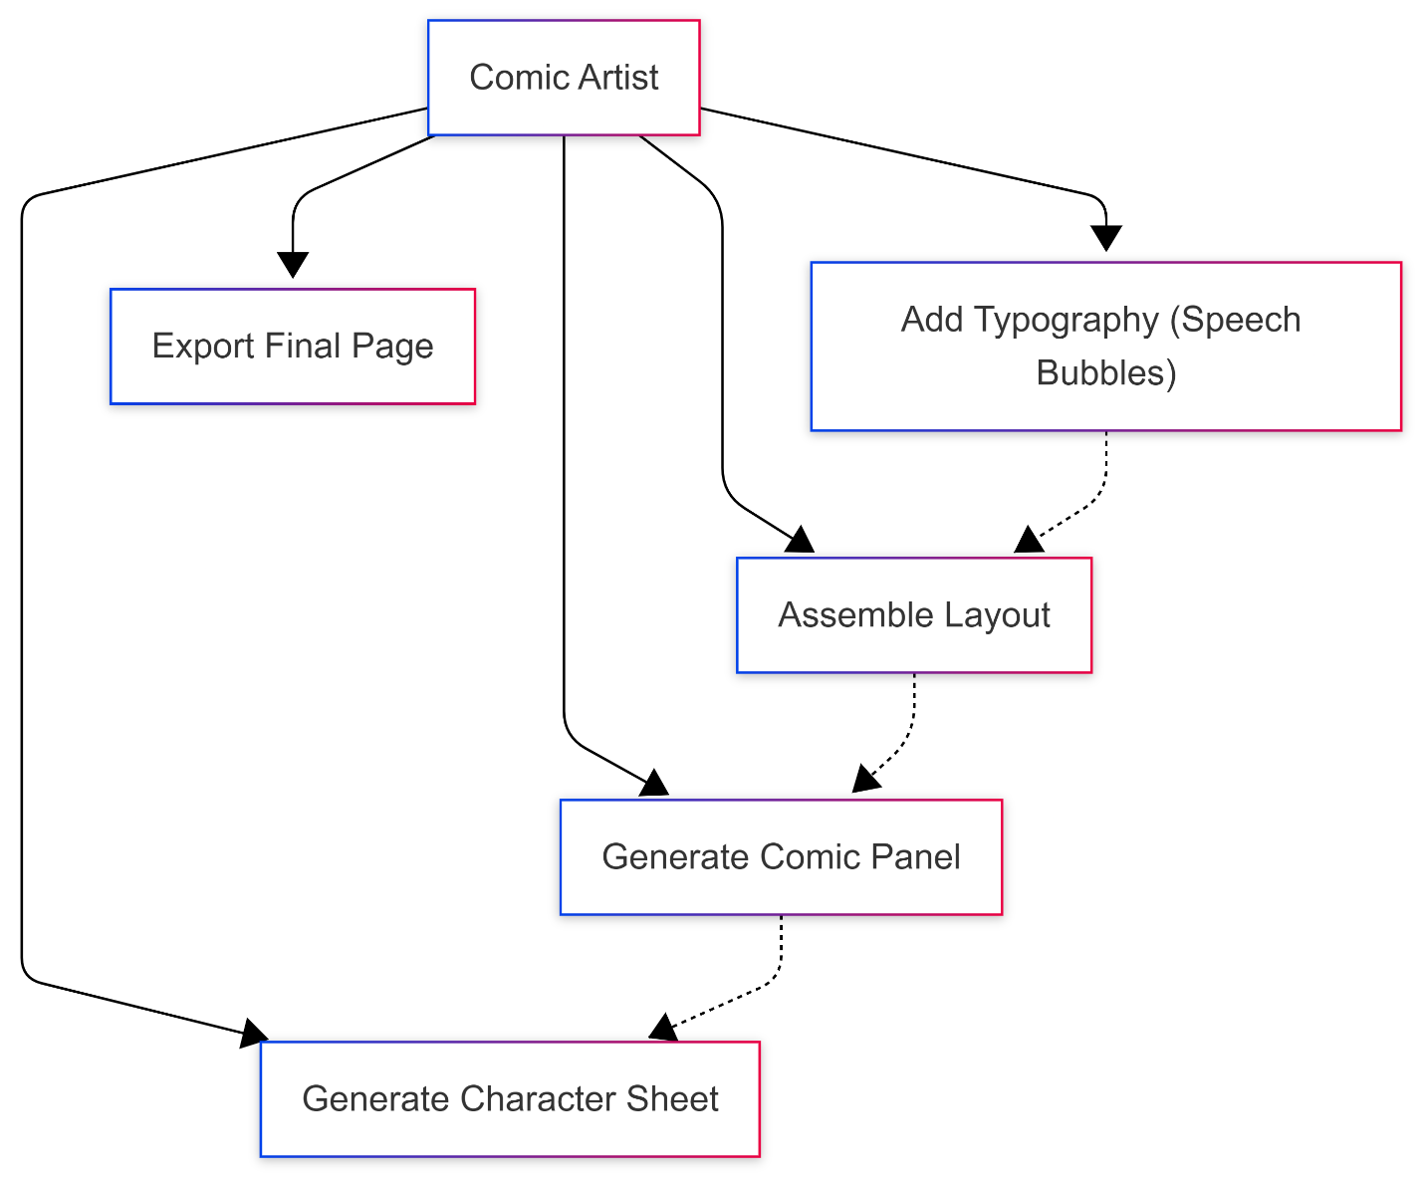
The system architecture supports three primary Use Cases, corresponding to the three major tabs in the UI:
- Use Case 1: Character Generation. The user inputs a physical description. The system executes a highly structured background workflow to generate a character sheet (showing the character from multiple angles) and saves the specific random seed and embedding for future use.
- Use Case 2: Panel Generation. The user selects an active character and inputs a scene description (e.g., "sitting at a desk"). The system merges the active character's metadata with the scene prompt and executes a generation workflow, resulting in an isolated comic panel.
- Use Case 3: Layout & Typography. The user creates a new comic page, selecting a grid layout (e.g., 3-panel manga). The user drags previously generated panels from their library into the grid slots. The user then adds vector speech bubbles, adjusts the text, and exports the final composition.

6.3. Sequence Diagrams
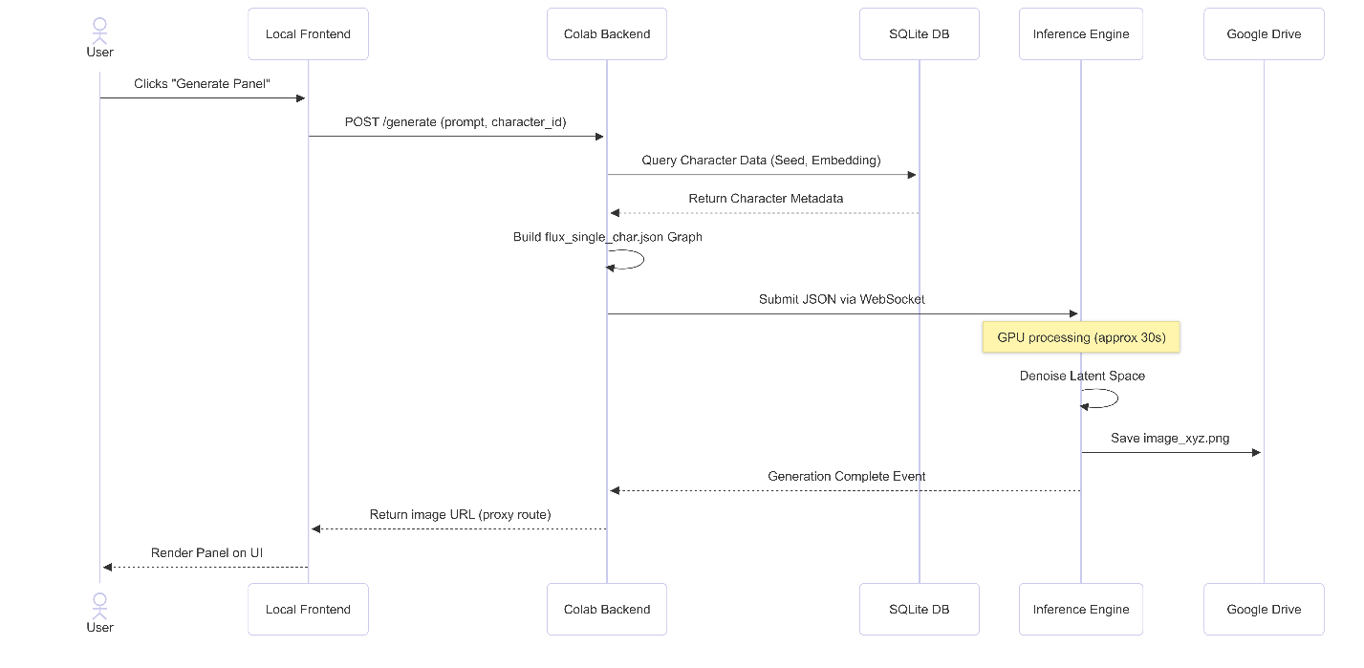
A critical sequence in the system is the Panel Generation Flow:
- The User clicks "Generate" on the frontend.
- The Next.js client sends an HTTP POST request containing the prompt and the character_id to the FastAPI backend.
- The FastAPI backend queries the SQLite database to retrieve the character's canonical prompt and specific random seeds.
- FastAPI dynamically constructs a JSON workflow graph, injecting the prompt, character data, and Style LoRA parameters.
- FastAPI submits the JSON graph to the ComfyUI API via WebSocket.
- ComfyUI executes the inference process on the GPU.
- Upon completion, ComfyUI saves the image to the mounted Google Drive.
- FastAPI returns the generated image URL to the Next.js client.
- The Next.js client fetches the image via a specialized proxy route (to bypass tunnel browser warnings) and updates the UI state.

7. System Architecture and Design

7.1. System Architecture
The AI Comic Studio employs a strictly decoupled, dual-node architecture designed to separate UI responsiveness from heavy mathematical computation.
- Client Node (Frontend): A Next.js application leveraging Server-Side Rendering (SSR) for static elements and heavily relying on client-side React hooks for canvas interactivity. All layout arithmetic (scaling slots, rotating text) occurs locally on the user's CPU.
- Compute Node (Backend): A transient Google Colab instance. The FastAPI layer acts as an abstraction API, intercepting high-level requests (e.g., "generate character X doing Y") and translating them into the highly specific, lower-level JSON graphs required by the ComfyUI inference engine.

7.2. Structural Models
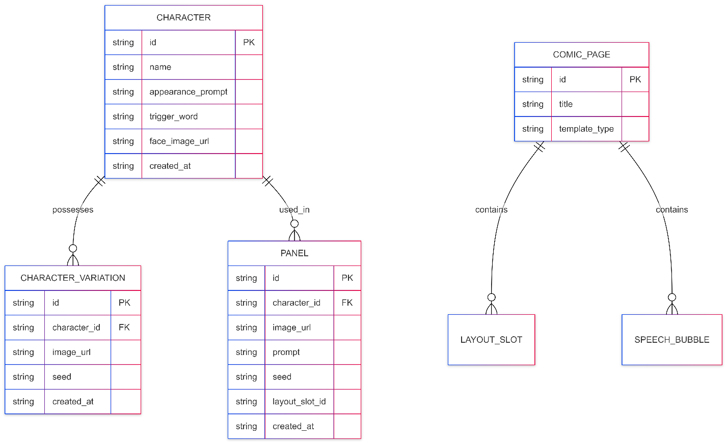
The structural integrity of the application relies on two primary abstractions:
- The Database Schema: Implemented in SQLite via SQLAlchemy. The schema establishes a one-to-many relationship where a single Character entity owns multiple Panels and CharacterVariations. A ComicPage owns multiple LayoutSlots and SpeechBubbles. This structured persistence ensures that users can close the application and resume their projects without losing generated assets.
- The JSON Graph Schemas: Rather than executing raw Python diffusion scripts, ComfyUI requires Directed Acyclic Graphs (DAGs) represented as JSON. The backend maintains specific template graphs for flux_single_char, flux_dual_char, and flux_background.

7.3. Behavioral Models
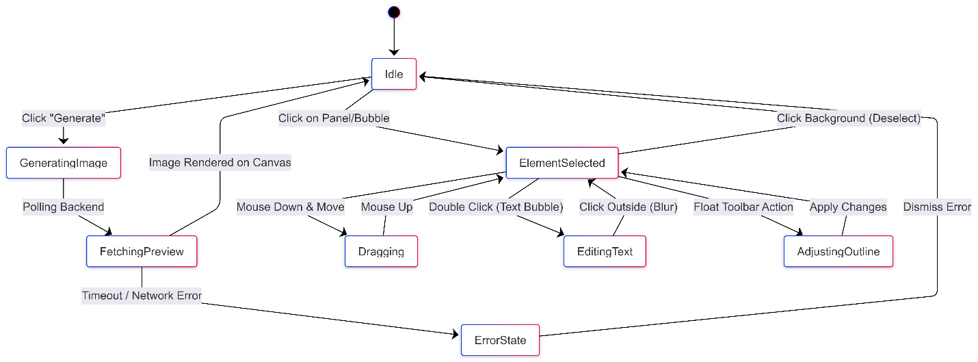
The most complex behavioral modeling occurs on the Frontend canvas, utilizing React-Konva and Zustand. Because the canvas must handle dragging, dropping, scaling, and z-index ordering across dozens of layers simultaneously, the system uses an Event-Driven Architecture. Selecting an element dispatches an action to the Zustand store, which triggers a localized re-render of the specific Konva Node (e.g., highlighting a speech bubble border) without causing the entire 4K image canvas to re-render, ensuring a smooth 60 FPS user experience.

8. System Implementation

8.1. Development Environment
The implementation spanned three separate development environments:
- VS Code (Windows): For all Next.js frontend development and Tailwind styling.
- Google Colab (Ubuntu Linux): For executing the backend, running PyTorch, and hosting the ngrok tunnel.
- Koyash & CivitAI Platforms: Utilized for model discovery, dataset scraping, and cloud-based LoRA training.

8.2. Code Structure
The repository is fundamentally split into two distinct codebases:
- /frontend: Contains the app/ directory for Next.js routing, the components/ directory (subdivided into /assembly, /character, /panel, and /text), and the store/ directory where all Zustand state managers (assemblyStore.ts, bubbleStore.ts, etc.) reside.
- /backend: Contains the FastAPI main.py entry point, the SQLite database.py configurations, and the critical services/ directory, which houses the comfyui_client.py and prompt_builder.py scripts responsible for orchestrating the AI.

8.3. The Style LoRA Training Pipeline (Data Preparation & Fine-Tuning)
A defining success of this capstone was the development of a custom Style LoRA to override the generic aesthetic of the base Flux.1 model. Training an AI model requires a rigorous data pipeline:

8.3.1. Data Collection
We scraped a massive dataset of high-quality comic art from platforms like CivitAI and professional digital art repositories. The collection focused specifically on obtaining a diverse range of camera angles (close-ups, wide shots, dynamic action poses) to ensure the model would not overfit to a single perspective.

8.3.2. Ethical & Technical Filtering
Raw web data is unsuitable for direct training. The dataset underwent a strict filtering process:
- Ethical Filtering: Automated and manual sweeps were conducted to remove any NSFW, violent, or culturally insensitive imagery.
- Technical Filtering: Images with low resolutions, severe JPEG artifacting, or intrusive watermarks were discarded. We enforced specific quality thresholds to ensure the AI learned only from crisp, professional line art and shading.

8.3.3. Data Preparation & Captioning
For a diffusion model to learn a style, it must understand what it is "looking" at. We utilized an advanced Vision-Language Model (VLM) to automatically generate highly descriptive text captions for every image in the dataset (e.g., "1girl, solo, wearing a blue school uniform, standing in a classroom, manga style line art, cel shading"). These text-image pairs were fed into the training algorithm. By appending a unique trigger token to these captions during the training loop, the model learned to mathematically associate our specific "comic style" with that token, allowing us to invoke it perfectly during inference.

9. MVP Development & Demonstration

9.1. MVP Definition
The Minimum Viable Product (MVP) was defined as an end-to-end software pipeline capable of capturing a user's prompt, maintaining a persistent character identity, generating narrative panels, and allowing the user to assemble a finished comic page complete with speech bubbles.

9.2. Implemented Features
The finalized MVP successfully implements:
- Persistent Character Library with automated Character Sheet generation.
- Intelligent Panel generation utilizing character data references.
- A robust Assembly Canvas allowing infinite manipulation of panels (cropping, zooming, flipping).
- A custom Typography Engine that renders speech bubbles, narration boxes, and "naked" plain text dynamically over the comic layout.

9.3. System Demonstration: "The Cat in the Classroom"
During the final sprint, the system was demonstrated by generating a multi-panel narrative. A single character ("a girl with a brown bob cut and blue school uniform") was generated. She was subsequently placed into four distinct narrative scenes (holding a presentation, pointing at a cat, holding a cat, and reacting in shock). The system flawlessly maintained the character's facial identity and the specific details of her uniform across all four shots, while the custom Style LoRA maintained the cel-shaded manga aesthetic. The panels were successfully assembled in the Next.js UI, and text bubbles were overlaid to complete the narrative.

10. Testing and Evaluation

10.1. Testing Strategy
Testing was divided into traditional software quality assurance (ensuring API reliability and UI performance) and generative model testing (ensuring prompt adherence and visual quality).

10.2. Generative Adherence Testing
To test the models, we executed a matrix of prompts against both SDXL and Flux.1. The prompts escalated in complexity from "1girl, close up" to "1girl in red jacket sitting at a table across from 1boy in blue shirt."
- Results: SDXL consistently failed the multi-character tests, blending the red and blue colors. Flux.1 passed 100% of the spatial and color-segregation tests.

10.3. Network Latency Testing
A critical non-functional requirement was managing the latency of downloading 2MB-5MB generated images from the remote Colab instance. Initial tests showed a jarring "white flash" when the UI attempted to render a newly fetched image. We mitigated this by engineering a custom VariationImage React component that displays a smooth, dark skeleton-loader until the HTTP response has fully resolved, drastically improving perceived performance.

11. Results and Discussion

11.1. Goal Attainment
The project successfully proved that the "single-prompt" comic generation paradigm is fundamentally flawed and that a decoupled, modular architecture is superior. By separating Character Generation, Panel Synthesis, and Layout Assembly, the AI Comic Studio grants the user a level of precision previously impossible with raw AI endpoints.

11.2. Ethical Considerations
Operating generative AI tools requires a conscious approach to ethics. The custom dataset utilized for the Style LoRA was strictly filtered to prevent the generation of harmful, violent, or NSFW content. Furthermore, this system is designed as an assistive tool for storytellers, automating the tedious drafting process rather than replacing human narrative intent.

11.3. Cost Analysis
A significant finding of this project is the democratization of high-end compute. Purchasing a local GPU capable of running 12-billion parameter models (like an RTX 4090 or RTX A6000) requires a capital expenditure of $2,000 to $5,000. By architecting the backend to run on Google Colab Pro, the system achieves the exact same generative power for roughly $10 per month, proving that professional AI workflows can be deployed economically via the cloud.

12. Conclusion and Future Work

12.1. Conclusion
The AI Comic Studio successfully bridged the gap between raw, unpredictable generative AI models and structured, professional creative workflows. By abandoning the expectation that an AI should generate a finished comic page from a single prompt, and instead building an interactive scaffolding that treats the AI as a panel-by-panel rendering engine, we solved the character consistency problem. The integration of Flux.1 and a custom-trained Style LoRA further proved that aesthetic cohesion can be mathematically enforced across a massive visual narrative.

12.2. Future Work
Future development will focus on three core areas:
- ControlNet Integration for Posing: While text prompting is powerful, allowing the user to upload a stick-figure sketch to physically drive the AI character's pose via ControlNet would drastically improve compositional control.
- Cloud Deployment: Migrating the backend from the transient Google Colab environment to a permanent, auto-scaling Kubernetes cluster (e.g., RunPod or AWS) to eliminate the need for manual startup scripts.
- Automated Storyboarding: Developing an LLM pipeline that automatically reads a script, parses it into distinct panels, and pre-populates the ComfyUI generation queue before the user even opens the canvas.

References & Appendices to follow in full document compilation.

13. Appendices

